1. Join Quota=Joining Quota (**don’t allow to create any more option**)(it should be created from a menue we will provide, not from here)
2. Move **Quota=** ‘Joining Quota’to **joining record Done**
3. Divorced = (Spouse Name should not be here) **Done**
4. CHILDREN DETAILS **(add a line is not working) working with an extra step pending**
5. **add Home District to personal information Added But Confusion is permanent address/district and home district same?**
6. **Educational Qualification এর মধ্যে GPA/CGPA column বাদ দিতে হবে+** **Grading System এর নাম বদলে Division/ CGPA করতে হবে done**
7. **Disciplinery Actions (Should Be Like=**

|  |  |  |  |  |
| --- | --- | --- | --- | --- |
| **Nature of offence** | **Date of Punishment** | **Punishment** | **Remarks** | **Upload Document** |

**Done**

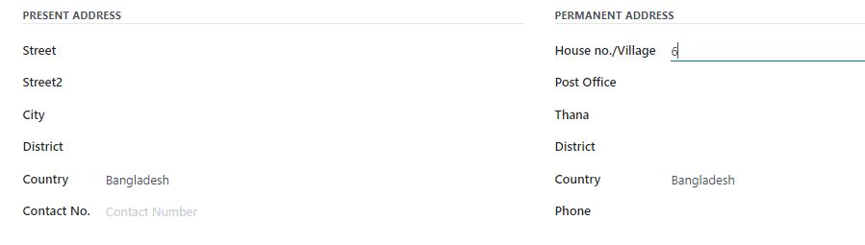

House

Street

post Office

Thana

District

**Pls omit country here**

House

Street

post Office

Thana

District

**Pls omit country here**

Done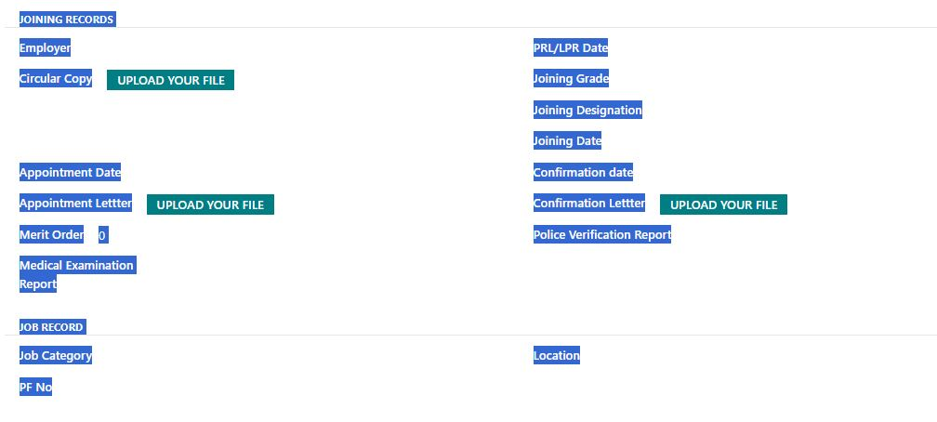

**09.** job record এখানে দরকার নেই (Posting and transfer এর আগে হবে।

**10.** **Posting and transfer part এ Posting and transfer কথাটা মুছে গেছে।**

|  |  |
| --- | --- |
| 11. Pls maintain the serial and include all of the following: (Under Joining Record) | |
| Employing Authority | Merit Order |
| Joining Designation | Joining Grade |
| Joining Date | Joining letter (Upload) |
| Circular Date | Circular Copy (Upload) |
| Appointment Date | Appointment letter (Upload) |
| Conformation Date | Conformation Letter (Upload) |
| PRL Date | Provident Fund No. |
| Police Verification Report (**Upload**) | Medical Examination Report (**Upload**) |
| Joining Quota (**Upload**)  **Ethnic Minority**  **Freedom fighter**  **Disability** |  |
| Job Category | Location |
| Batch | Cadre (For Deputation) |

Done